|  |  |
| --- | --- |
| Internship Project Title | RIO-125: Automate Emotion Analysis of Textual Comments and Feedbacks |
| Name of the Company | TCS iON |
| Name of the Industry Mentor | Mr. Debashis Roy |
| Name of the Institute | Vishwakarma University, Pune |

|  |  |  |  |  |
| --- | --- | --- | --- | --- |
| Start Date | End Date | Total Effort (hrs.) | Project  Environment | Tools used |
| 19/03/2024 | 25/04/2024 | 125 | Python | Visual Code Extension – Pandas,  NLTK (Natural Language Toolkit),  TextBlob, Scikit-learn,  Matplotlib, Seaborn,  GridSearchCV, StandardScaler,  Pipeline, CountVectorizer,  Tokenizer, Sequential  Embedding, LSTM (Long ShortTerm Memory), Dense, SpatialDropout1D, EarlyStopping, etc. |

**TABLE OF CONTENT**

* Acknowledgements
* Objective
* Introduction / Description of Internship
* Internship Activities
* Approach / Methodology
* Assumptions
* Exceptions / Exclusions
* Charts, Table, Diagrams
* Algorithms
* Challenges & Opportunities
* Risk Vs Reward
* Reflections on the Internship
* Recommendations
* Outcome / Conclusion
* Enhancement Scope
* Link to code and executable file
* Research questions and responses

# ACKNOWLEDGEMENT

I am deeply thankful for the steadfast support and guidance I received throughout my project, RIO-125: Automate Emotion Analysis of Textual Comments and Feedbacks. My heartfelt gratitude goes to my industry mentor, Mr. Debashis Roy from TCSiON, and my academic mentor, ----- from Vishwakarma University. Their relentless encouragement was instrumental in my journey.

I would also like to express my sincere appreciation to TCS-iON and Vishwakarma University for providing me with this invaluable opportunity, which has greatly enhanced my understanding of the industry. I want to highlight that I completed this project independently, without any external help.

# OBJECTIVE

To create sophisticated deep learning algorithms designed to accurately identify different types of emotions within English sentences or lengthy paragraphs, with the primary objective of precisely predicting the overall emotion expressed by the entire text.

# INTRODUCTION/DESCRIPTION OF THE INTERNSHIP

Embarking on an exciting journey, this internship explores the field of teaching computers to interpret emotions from written text. By leveraging the Flipkart customer reviews dataset, we will employ deep learning techniques to enable computers to identify emotions such as happiness, sadness, and other nuanced emotions. Our goal is to empower our digital counterparts with the capability to accurately gauge the emotional tone of any text, whether it’s a short message or a lengthy essay. Through this endeavor, we aim to enhance our computer systems' ability to understand human emotions, capturing the diverse range of emotions expressed in written language.

# INTERNSHIP ACTIVITIES

The internship activities include the following:

1. Research and study emotion analysis and deep learning algorithms.

2. Collect diverse textual data, preprocess it, and prepare it for training.

1. Experiment with various deep learning architectures for emotion analysis.
2. Train models, evaluate their performance, and iterate for improvement.
3. Explore hyperparameter tuning techniques for model optimization.
4. Validate models generalization ability with unseen data.
5. Document the process and prepare reports summarizing findings.

# APPROACH/METHODOLOGY

The following Approaches and Methodologies were used in the project:

1. **Text Preprocessing**:

* Tokenization: This process breaks the text into individual words or tokens, simplifying the analysis.
* Part-of-Speech (POS) Tagging: This step assigns grammatical categories to each token, such as noun, verb, or adjective, which can be helpful for tasks like lemmatization.
* Lemmatization: This technique reduces words to their base or dictionary form to maintain consistency in word representation. For instance, "running" is reduced to "run."
* Removing Punctuation and Stop Words: This step eliminates irrelevant elements from the text, focusing on the words that hold more meaningful content.

1. **Emotion Analysis**:

* Emotion Analysis: This process identifies the emotion expressed in a text. In this context, TextBlob is used to provide a polarity score, indicating whether the emotion is positive, negative, or neutral.
* Emotion Labeling: Based on the polarity score, each review is assigned a corresponding emotion label.

1. **Regression Analysis**:

• Linear Regression: This statistical method models the relationship between independent variables (such as emotion polarity) and a dependent variable (product rating).

• Model Training: The model is trained to predict product ratings based on emotion polarity scores.

• GridSearchCV: This technique is used to systematically search for the best hyperparameters for the linear regression model, optimizing its performance.

1. **Hyperparameter Tuning**:

• Hyperparameters: These are parameters that control the learning process of a machine learning algorithm.

• GridSearchCV: This technique exhaustively searches through a specified parameter grid to find the optimal hyperparameters.

• Optimization: In this case, the fit_intercept parameter of the linear regression model is optimized to enhance its predictive capability.

1. **Training Multiple Models**:

• Multiple Linear Regression Models: Different models with varying hyperparameters are trained to explore a range of configurations.

• **Comparison of Models**: This approach facilitates the evaluation of model performances, allowing for the selection of the best-performing model based on metrics like Mean Squared Error (MSE).

1. **Adding n-Grams**:

* N-grams: N-grams are contiguous sequences of n items from a given sample of text. In this context, unigrams (single words) and bigrams (pairs of adjacent words) are utilized.
* CountVectorizer: This tool converts text data into numerical feature vectors, taking into account both unigrams and bigrams.
* Expanded Feature Space: By including n-grams, the feature space is broadened, capturing more context from the text data and potentially enhancing the model's predictive performance.

1. **Deep Learning for Emotion Analysis**:

* Deep Learning Models: Deep learning models, especially recurrent neural networks (RNNs) such as LSTM (Long Short-Term Memory), are particularly adept at handling sequential data like text.
* Pattern and Dependency Learning: The LSTM model is designed to learn patterns and dependencies within the sequence of words, aiding in predicting emotion labels.
* Training and Evaluation: The model is trained on pre-processed text data and evaluated using metrics like classification accuracy to assess its performance.

# ASSUMPTIONS

1. **Text Representation**: The emotion analysis is based solely on the text content of reviews, without considering other factors like user demographics or product features.
2. **Language**: The analysis assumes that all reviews are in English, as the NLTK library and TextBlob are primarily designed for English text processing.
3. **Accuracy of Emotion Polarity**: It is assumed that the emotion polarity scores generated by TextBlob are sufficiently accurate for this task. However, more sophisticated models trained on specific domains might capture nuances in emotion more effectively.
4. **Labeling of Emotion**: The emotion labels (positive, negative, neutral) derived from polarity scores are assumed to adequately represent the emotion expressed in the reviews, though there may be instances where the polarity score does not fully capture the emotion.
5. **Relationship Between Emotion and Rating**: There is an assumption of a correlation between the emotion expressed in reviews and the corresponding product ratings, with positive emotions typically correlating with higher ratings and negative emotions with lower ratings.
6. **Quality of Data**: The dataset (flipkart.csv) is assumed to contain relevant and representative customer reviews and corresponding ratings, which are crucial for the quality and accuracy of the emotion analysis and regression models.
7. **Validity of Preprocessing Steps**: The preprocessing steps, including tokenization, POS tagging, lemmatization, punctuation removal, and stop words removal, are assumed to effectively clean and normalize the text data, thereby enhancing the performance of subsequent analysis.
8. **Model Selection**: The choice of models (linear regression, LSTM, ensemble of LSTM and CNN) is considered appropriate for the task of emotion analysis and rating prediction based on customer reviews. The effectiveness of each model depends on factors such as data quality, feature representation, and model complexity.
9. **Hyperparameter Tuning Impact**: It is assumed that hyperparameter tuning using techniques like GridSearchCV improves the performance of the linear regression model, enhancing the accuracy of emotion prediction and rating estimation.
10. **Evaluation Metrics**: Mean Squared Error (MSE) is assumed to be an appropriate evaluation metric for regression analysis, measuring the accuracy of predicted ratings compared to actual ratings. For deep learning models, accuracy is used as the evaluation metric, reflecting the percentage of correctly predicted emotion labels.

# EXCEPTIONS/EXCLUSIONS

The project consists the following exceptions/exclusions:

1. **Sarcasm and Irony**: Emotion analysis may struggle to accurately identify sarcasm or irony, as these nuances are often context-dependent and challenging to detect algorithmically. Reviews containing sarcasm or irony might not be correctly interpreted by tools like TextBlob.
2. **Emojis and Emoticons**: Emotion analysis typically focuses on textual content and may not account for emojis or emoticons. Since emojis can convey emotions, their exclusion might lead to misinterpretation of emotion.
3. **Subjectivity and Context**: Algorithms for emotion analysis often overlook the subjective nature of language and the importance of context in understanding emotion. Phrases may carry different meanings based on context, potentially leading to inaccuracies.
4. **Language Variations and Slang**: Models trained on standard English may struggle with informal language, dialects, or slang. Language variations across different demographics or regions can introduce biases or inaccuracies in emotion analysis.
5. **Negation and Amplification**: Emotion analysis tools may not effectively handle negation or amplification, where emotion is reversed or intensified. For example, "not bad" could be misinterpreted as positive emotion despite containing the negation "not."
6. **Length and Complexity of Text**: The performance of emotion analysis algorithms can vary with the length and complexity of the text. Short reviews may lack context, while longer reviews may contain nuanced emotions requiring more sophisticated analysis.
7. **Domain-Specific Language**: Models trained on general text may not generalize well to domain-specific language or terminology. Reviews in specialized fields may contain jargon not adequately captured by the emotion analysis model.
8. **Cultural and Social Factors**: Emotion analysis may overlook cultural or social factors that influence emotion interpretation. Cultural nuances, societal norms, and demographic differences can affect how emotion is expressed and perceived, challenging universal model development.
9. **Data Imbalance**: The dataset may suffer from class imbalance, where one emotion (e.g., positive) is more prevalent than others (e.g., negative or neutral). Imbalanced data can skew model performance and lead to biased results.
10. **External Factors**: Emotion in reviews can be influenced by external factors like marketing campaigns, competitor actions, or current events, introducing noise or confounding variables that affect emotion analysis accuracy.

# CHARTS, TABLE, DIAGRAMS

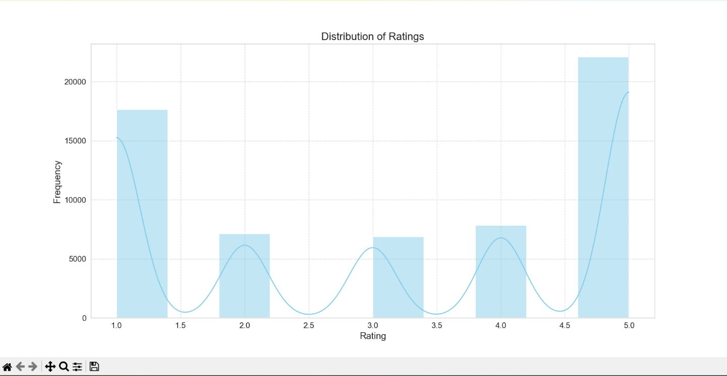

Histogram of customer ratings for various products on the online shopping platform "Flipkart." The graph displays ratings ranging from 1.0 to 5.0 on the x-axis and their corresponding frequencies on the y-axis. Notably, there is a scarcity of ratings between 1.0 and 3.5, with a slight increase noted at 3.0. Subsequently, there is a notable rise in frequency at 4.0, followed by a dip at 4.5, and a sharp peak at 5.0, indicating a significant clustering of ratings at the highest value.

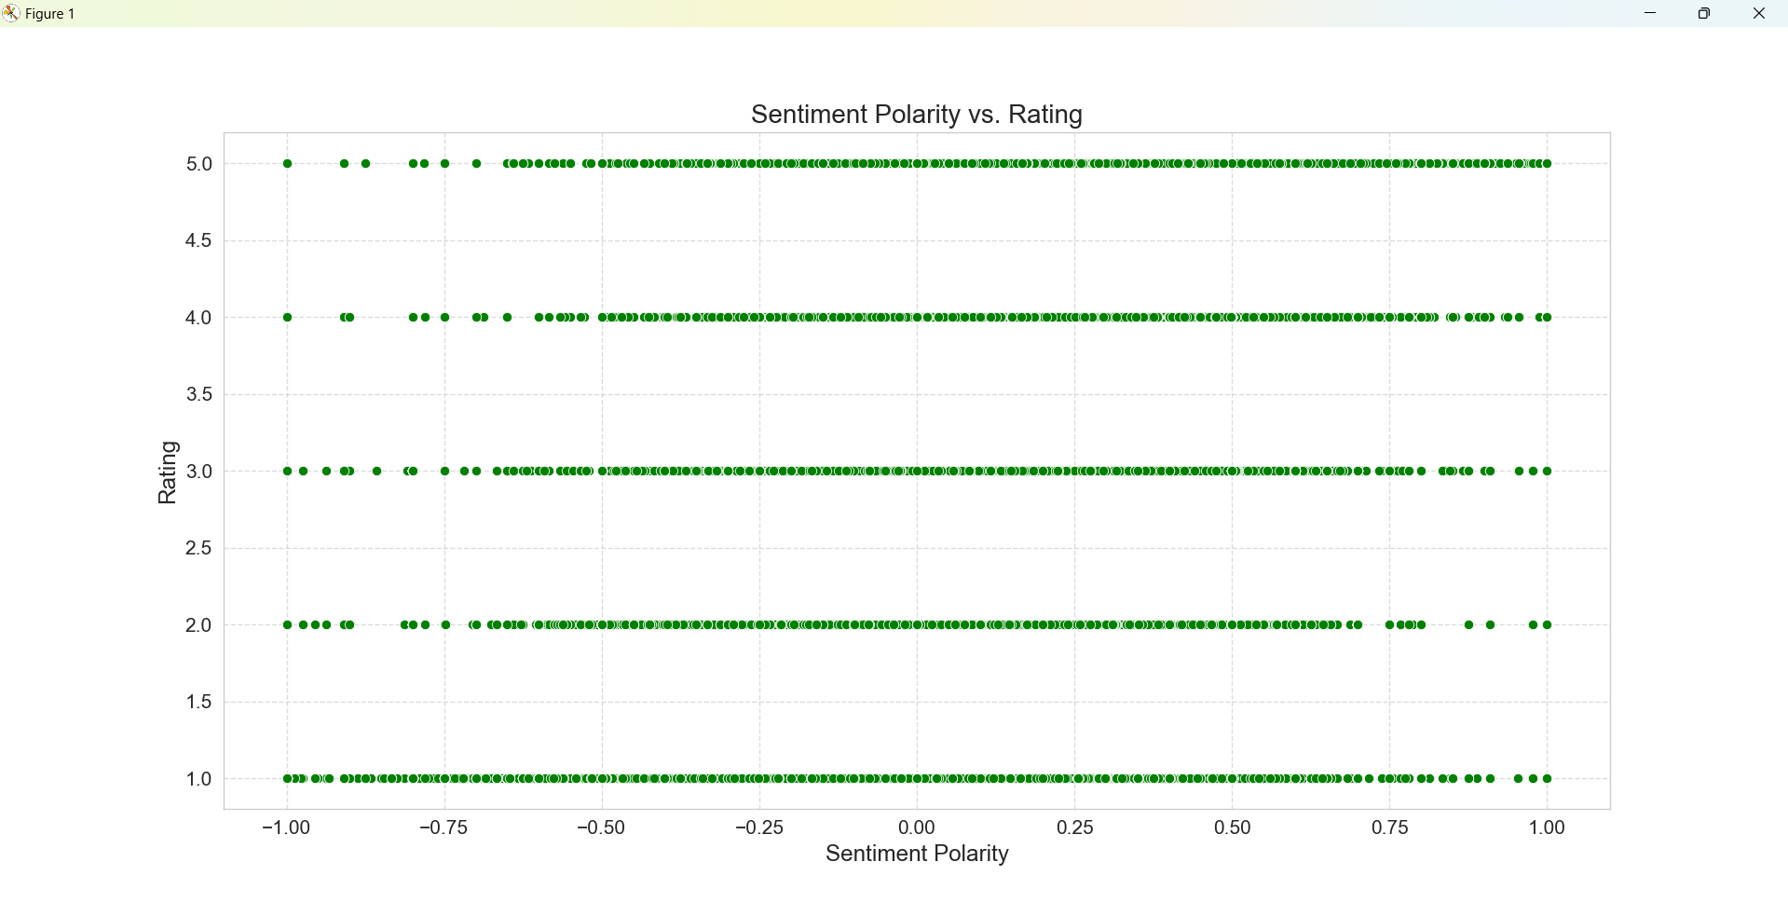

Scatter Plot titled "Emotion Polarity vs. Rating" which illustrates the relationship between the emotion polarity (ranging from -1.00 to 1.00) and the rating (ranging from 1.0 to 5.0). Green dots represent data points, indicating varying emotion polarities and ratings. Data points cluster around integer rating levels, with denser concentrations near zero emotion polarity. The highest concentration of points aligns with the top rating (5.0), predominantly displaying positive emotion polarities. Lower ratings (1.0 to 2.0) exhibit fewer data points dispersed across both negative and positive emotion polarities, suggesting a broader range of opinions when ratings are lower.

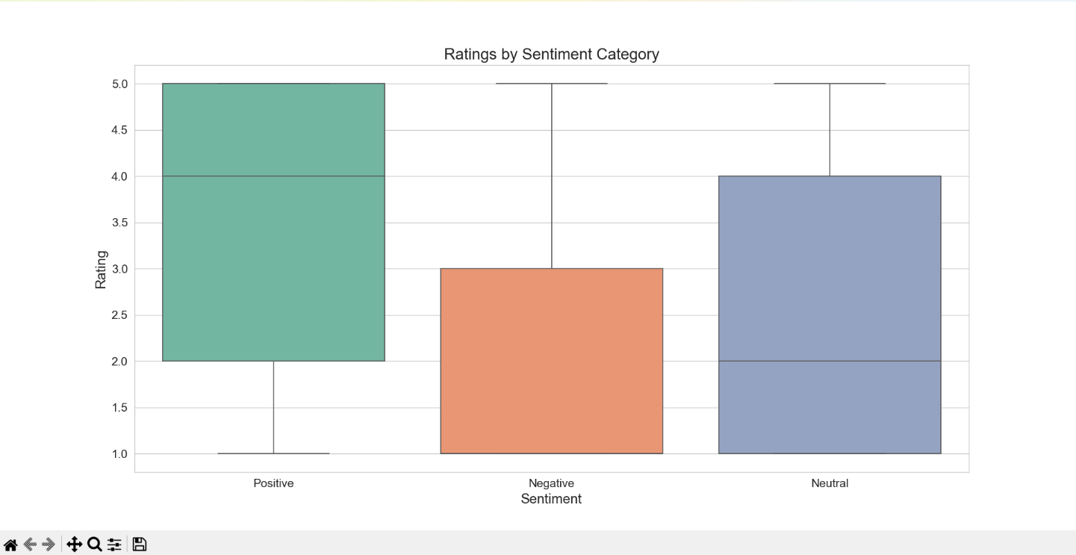

Boxplot titled "Ratings by Emotion Category" which illustrates the average ratings assigned to Positive, Negative, and Neutral emotion categories. Positive emotion registers the highest average rating, followed by Neutral and Negative emotions. Notably, outliers are visible within the Positive and Neutral categories, signifying substantial deviations from the average ratings within these groups.

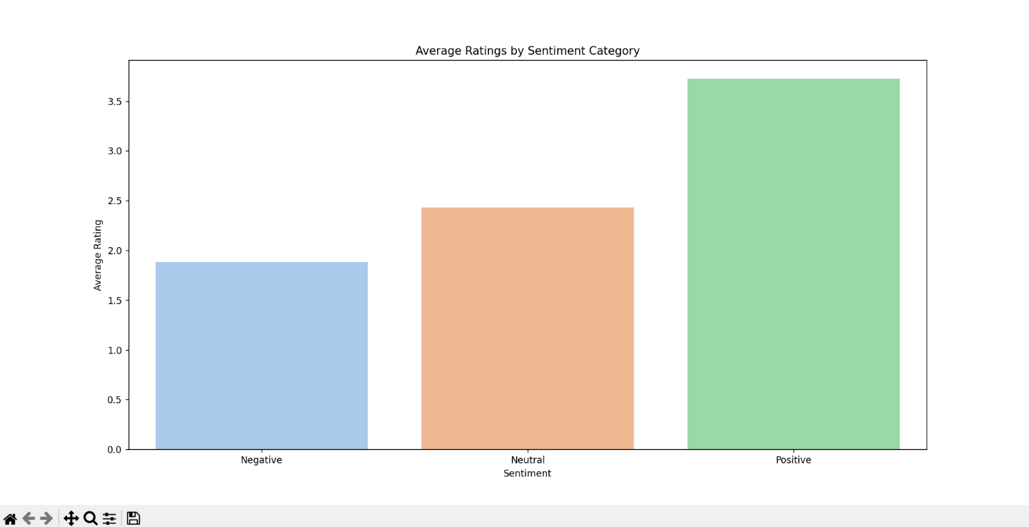

Vertical Bar Chart titled "Average Ratings by Emotion Category," depicting the average customer emotions categorized as Positive, Negative, or Neutral. The chart highlights that Positive emotion garners the highest average rating, suggesting that customers are notably satisfied with the products or services. Following Positive emotion, Neutral emotions range between 3 and 4, indicating moderate satisfaction. Negative emotions, ranging between 1 and 2, represent the lowest average ratings, suggesting dissatisfaction among customers.

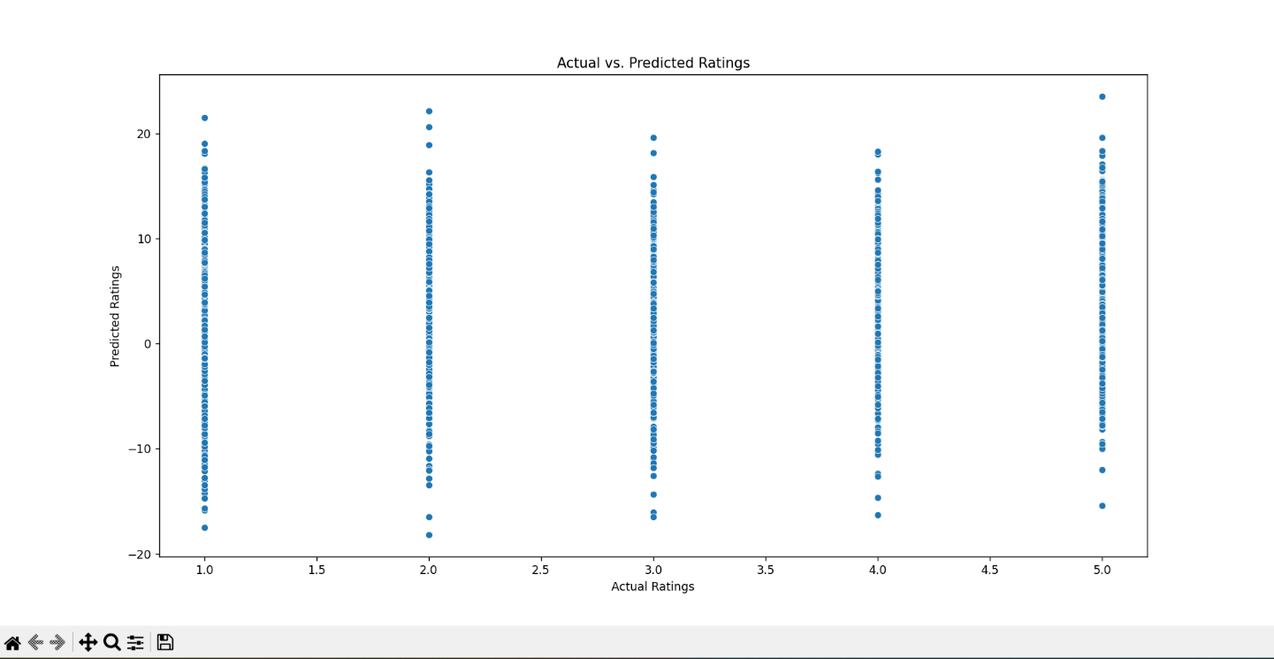

Scatterplot for "Actual Ratings" against "Predicted Ratings" using blue dots to denote individual data points. Actual ratings ranging from 1.0 to 5.0 are plotted on the x-axis, while predicted ratings are represented on the y-axis within the same range. Notably, for lower actual ratings, such as 1.0, the predicted ratings exhibit wide dispersion, ranging from 1.5 to over 5.0, indicating varying levels of accuracy in the prediction model. Conversely, as actual ratings increase, particularly for ratings of 4.0 and 5.0, predicted ratings cluster closer to the actual values with less variation. Overall, while the model demonstrates greater accuracy for higher actual ratings, it lacks consistency across all rating levels, suggesting room for improvement.

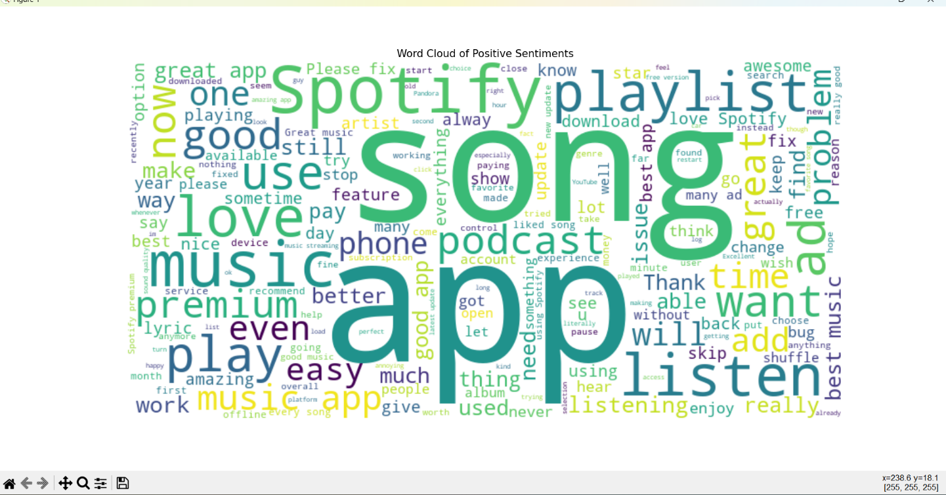

word cloud representing positive emotions. In this visual representation, words associated with positive emotions are depicted, with the size of each word proportional to its frequency or significance in the positive emotion context.

**ALGORITHMS**

**1. Text Preprocessing:**

* Text preprocessing techniques such as tokenization, part-of-speech (POS) tagging, lemmatization, punctuation removal, and stop word removal are employed to clean and prepare textual data for further analysis. These steps ensure that the text data is standardized and noise-free, facilitating accurate analysis and model training.

**2. Emotion Analysis with TextBlob:**

* TextBlob, a Python library for processing textual data, is utilized for emotion analysis. It provides tools for processing text, including part-of-speech tagging, noun phrase extraction, emotion analysis, and more.
* Emotion analysis is performed by analyzing the polarity of text using TextBlob's pre-trained emotion analysis model. The model provides a polarity score that indicates the emotion's positivity, neutrality, or negativity.
* The emotion polarity scores are categorized into three labels: Positive, Neutral, and Negative based on the polarity value.

**3. Linear Regression for Rating Prediction:**

* Linear regression is employed to model the relationship between emotion polarity scores and product ratings. This approach helps in predicting product ratings based on the emotion expressed in customer reviews.
* The emotion polarityscores are used as features (independent variables), and the product ratings are treated as the target variable (dependent variable).
* The model is trained using the least squares method to minimize the mean squared error (MSE) between predicted and actual ratings.

**4. Hyperparameter Tuning with Grid Search:**

* Grid search with cross-validation is utilized to optimize the hyperparameters of the linear regression model. This process involves systematically searching through a range of hyperparameter values to find the best configuration.
* The hyperparameters explored include whether to fit the intercept in the linear regression model.
* Grid search helps to find the best combination of hyperparameters that minimizes the mean squared error (MSE) on the validation set, ensuring optimal model performance.

**5. Pipeline with CountVectorizer and Linear Regression:**

* A pipeline is constructed using CountVectorizer and Linear Regression for text feature extraction and modeling. The pipeline ensures that the data transformation and model training steps are streamlined and consistent.
* CountVectorizer is used to convert text data into numerical features by counting the frequency of words (unigrams and bigrams). This step transforms the text into a format suitable for machine learning models.
* Linear Regression is then applied to predict product ratings based on the extracted text features, leveraging the numerical representation of the text.

**6. Deep Learning Model with LSTM and CNN:**

* A deep learning model architecture is designed using Long Short-Term Memory (LSTM) and Convolutional Neural Network (CNN) layers. These architectures are well-suited for handling sequential data like text.
* The LSTM layer captures sequential patterns in text data, such as the order of words and dependencies between them, which is crucial for understanding context and emotion.
* The CNN layer extracts local features, identifying important patterns within chunks of text, such as key phrases or expressions.
* The model is trained to classify emotion into three categories: Positive, Neutral, and Negative. This classification helps in understanding the overall emotion expressed in the reviews.
* The ensemble model combines the predictions of the LSTM and CNN models to enhance overall performance. This approach leverages the strengths of both models, improving the accuracy and robustness of emotion analysis.

# CHALLENGES & OPPORTUNITY

**CHALLENGES:**

1. **Finding Good Data:**

Acquiring a substantial and diverse dataset of text that clearly conveys emotions (such as happiness, sadness, or neutrality) is essential for training models in emotion analysis. However, sourcing such data can be challenging due to the variability in how emotions are expressed in text.

1. **Understanding Different Ways of Saying Things:**

People express emotions in varied ways, often using sarcasm, humor, or other nuanced expressions. This variability can pose difficulties for models in accurately interpreting the intended emotion, especially when the context is subtle or ambiguous.

1. **Making Computers Understand Negatives:**

Interpreting phrases that involve negation, like "not bad," can be challenging for models. These phrases often carry a positive connotation despite the presence of negative words, requiring the model to grasp the contextual meaning beyond the literal words used.

1. **Making Sure Models Work Everywhere:**

Models trained on specific datasets (e.g., movie reviews) may not generalize well to different contexts (e.g., feedback about food or services). Ensuring that models can adapt and perform accurately across various domains and types of content is a significant challenge in emotion analysis.

**Opportunities:**

1. **Using New and Better Techniques:**

Researchers are continuously developing advanced methods for improving language understanding in computers. For instance, large-scale models that learn from extensive text corpora can enhance the accuracy of emotion analysis by capturing more complex patterns and nuances in language.

1. **Looking at More Than Just Words:**

To improve emotion understanding, we can incorporate multimodal data, such as images, sounds, or videos, alongside text. This approach allows computers to analyze whether visual or auditory cues align with the emotions expressed in the text, leading to a more comprehensive understanding of emotions.

1. **Making Computers Smarter for Specific Topics:**

Tailoring emotion analysis models to specific domains, such as healthcare or finance, involves training them with domain-specific data. By providing models with a wealth of examples from these fields, we can enhance their ability to accurately interpret emotions relevant to particular industries.

1. **Making Computers Explain Themselves:**

Enhancing the interpretability of emotion analysis models involves developing techniques that allow computers to explain their reasoning. By understanding the rationale behind a model’s emotion classification, users can trust and validate the model’s decisions, improving transparency and reliability.

# RISKS vs REWARDS

**Risks:**

1. **Misunderstanding the Emotions:**

* Risk**:** The computer may misinterpret emotions expressed in text, leading to incorrect emotion analysis.
* Impact**:** This misinterpretation could result in erroneous decisions or actions based on the computer's flawed understanding of emotions.

1. **Getting Stuck on Training:**

* Risk**:** The model might become overly specialized in the training examples it has seen and struggle with unfamiliar inputs.
* Impact**:** This limitation could reduce the model’s effectiveness in real-world scenarios where it encounters novel or varied expressions of emotion.

1. **Having Biased Data:**

* Risk**:** The training data might reflect biases that favor certain opinions or demographics over others.
* Impact**:** This bias could lead to unfair or inaccurate results, especially in sensitive applications like hiring or financial assessments.

1. **Making Things Too Complicated:**

* Risk**:** Excessive complexity in the emotion analysis approach may make the system slow or difficult to use.
* Impact**:** This complexity could hinder the system’s practical application, reducing its overall usefulness and user satisfaction..

**Rewards:**

1. **Making Better Choices:**

* Reward**:** Accurate emotion analysis enables businesses to make informed decisions based on consumer feedback.
* Impact**:** Improved decision-making can lead to better products, increased customer satisfaction, and enhanced business success.

1. **Making Things Easier for People:**

* Reward**:** Integrating emotion analysis into applications can enhance user interactions by better aligning with their needs and preferences.
* Impact**:** This can lead to more engaging and satisfying user experiences, making technology more beneficial and enjoyable.

1. **Using Resources Wisely:**

* Reward**:** Emotion analysis helps companies identify key trends and areas of interest, allowing for more strategic allocation of resources.
* Impact**:** Efficient resource management can reduce waste and improve overall business performance.

1. **Staying Ahead of the Game:**

* Reward**:** Businesses with strong emotion analysis capabilities can quickly adapt to shifts in consumer preferences.
* Impact**:** This agility can provide a competitive advantage, attracting more customers, fostering growth, and establishing industry leadership.

Top of Form

Bottom of Form

# REFLECTION ON THE INTERNSHIP

**1.Learning Opportunity:**

* Overview**:** The internship provided a valuable learning experience, enabling me to acquire practical skills in natural language processing (NLP) and emotion analysis.
* Details**:** Engaging in tasks such as text preprocessing, emotion labeling, and model evaluation significantly enhanced my understanding of NLP techniques and their practical applications.

**2. Hands-On Experience:**

* Overview**:** Working directly with code and real-world datasets offered me hands-on experience in applying machine learning models.
* Details**:** By implementing algorithms like linear regression, grid search, and deep learning architectures, I gained practical insights into model development and evaluation processes.

**3. Challenges Faced:**

* Overview**:** The emotion analysis project presented several challenges, including complexities in data preprocessing, model selection, and hyperparameter tuning.
* Details**:** Addressing these challenges required critical thinking, problem-solving skills, and iterative experimentation to identify and implement optimal solutions.

**4. Opportunities Explored:**

* Overview**:** The internship provided opportunities to explore various methods for emotion analysis, encompassing both traditional machine learning and deep learning techniques.
* Details**:** Experimenting with different algorithms and models allowed me to evaluate their strengths, weaknesses, and applicability to various scenarios.

**5. Reflections on Emotion Analysis:**

* Overview**:** Emotion analysis emerged as a powerful tool for deriving insights from textual data, applicable in areas like customer feedback and social media monitoring.
* Details**:** However, I also recognized its limitations, such as potential misinterpretation, biases in training data, and challenges in capturing nuanced emotions accurately.

**6. Future Directions:**

* Overview**:** Looking ahead, I plan to further refine my NLP and emotion analysis skills by exploring advanced techniques and models.
* Details**:** This includes delving into transfer learning, contextual embeddings, and domain-specific emotion analysis, as well as focusing on model interpretability and ethical considerations in AI for responsible and fair deployment of emotion analysis technologies.

# RECOMMENDATIONS

Here are some recommendations for the project:

1. **Use High-Quality Data:**

* Overview**:** Ensure that the data used for training your emotion analysis model is clean, accurate, and current.
* Details**:** High-quality data is essential for training effective models and achieving reliable results.

1. **Understand Nuanced Emotions:**

* Overview**:** Go beyond simple positive, negative, or neutral classifications by evaluating the intensity of emotions.
* Details**:** Assessing the strength of emotions can provide a more detailed understanding of user feelings.

1. **Consider Context:**

* Overview**:** Factor in the context or subject matter of the text, as this can influence the emotion.
* Details**:** Words like "good" might convey different emotions in various contexts, such as a movie review versus a restaurant review.

1. **Incorporate Multimodal Data:**

* Overview**:** Explore integrating non-textual data, such as images, sounds, or videos, to enhance emotion analysis.
* Details**:** Combining text with other data forms can provide a richer understanding of emotions.

1. **Focus on Specific Aspects:**

* Overview**:** Analyze emotions about particular elements mentioned in the text, such as product features or service aspects.
* Details**:** This targeted approach helps in understanding detailed feedback and improving specific areas.

1. **Customize for Different Domains:**

* Overview**:** Adapt your emotion analysis model to work effectively across various topics or industries.
* Details**:** Tailoring the model to specific languages or terminologies used in different sectors can enhance its accuracy.

1. **Enhance Interpretability:**

* Overview**:** Make the decision-making process of your emotion analysis model transparent and easy to understand.
* Details**:** Providing clear explanations for the model's decisions helps in building trust and usability.

1. **Ensure Fairness and Privacy:**

* Overview**:** Address fairness and privacy concerns in your emotion analysis system.
* Details**:** Ensure that the model treats all individuals fairly and respects their privacy.

1. **Incorporate Feedback:**

* Overview**:** Continuously improve the emotion analysis model based on user feedback.
* Details**:** Actively seek and integrate suggestions to refine and enhance the system.

1. **Collaborate and Share Knowledge:**

* Overview**:** Collaborate with others and share your findings to advance emotion analysis techniques.
* Details**:** Working together and learning from peers can drive improvements and innovation in the field.

# OUTCOME/CONCLUSIONS

The outcomes and conclusions are as follows:

1. **Regression Analysis:**

* Performance**:** The linear regression model exhibited a mean squared error (MSE) of approximately 1.0146. Lower MSE values suggest that the model's predictions are reasonably accurate, indicating effective prediction of ratings based on emotion polarity.

1. **Hyperparameters:**

* Optimization**:** Grid search cross-validation identified that fitting the intercept (fit_intercept: True) was the optimal hyperparameter configuration for the linear regression model. This choice resulted in the best model performance with an MSE of 1.0146, confirming the benefit of including the intercept in the model.

1. **Applying Multiple Hyperparameters for Best Configuration:**

* Finding**:** Among the various hyperparameters tested, fitting the intercept (fit_intercept: True) achieved the lowest MSE of around 1.0146. This underscores the importance of including the intercept for optimizing model performance.

1. **N-Grams:**

* Impact**:** Incorporating both unigrams and bigrams in the feature extraction process led to improved predictive performance, with an MSE of approximately 0.721. This indicates that using n-grams enhanced the model’s ability to accurately predict ratings from text reviews.

1. **Deep Learning Model:**

* Accuracy**:** The deep learning model achieved a high test accuracy of approximately 97.40% in classifying emotions into Positive, Neutral, and Negative categories. This demonstrates its effectiveness in detecting and categorizing emotions from textual data.

1. **Using LSTM and CNN for Fine-Tuning:**

* Outcome**:** The ensemble model combining LSTM and CNN architectures did not show a significant improvement in accuracy compared to individual models. With training and validation accuracies around 89%, the ensemble model's test accuracy was approximately 89.37%. Further refinement and experimentation may be needed to enhance its performance.

# ENHANCEMENT SCOPE

1. **Feature Engineering:**

* Objective**:** Enhance the model’s performance by incorporating additional features such as review length, presence of emoticons, and other text attributes. These features can provide more context and help the model better understand the emotion conveyed in reviews.

1. **Advanced Text Preprocessing:**

* Objective**:** Improve text preprocessing by implementing spell checking and handling contractions. This will ensure cleaner and more consistent text data, which can lead to more accurate emotion analysis.

1. **Fine-Tuning Hyperparameters:**

* Objective**:** Optimize hyperparameters such as learning rate and batch size to improve model performance. Fine-tuning these parameters can help achieve better convergence and overall accuracy.

1. **Ensemble Learning:**

* Objective**:** Combine predictions from multiple models (e.g., linear regression, LSTM, CNN) to leverage their individual strengths and improve overall accuracy. Ensemble methods can provide more robust predictions by aggregating results from different models.

1. **Transfer Learning:**

* Objective**:** Use pre-trained models like BERT (Bidirectional Encoder Representations from Transformers) to leverage state-of-the-art NLP techniques for emotion analysis. Transfer learning can significantly enhance model performance by utilizing knowledge from large-scale pre-training.

1. **Domain-Specific Customization:**

* Objective**:** Customize emotion analysis models for specific industries or domains (e.g., healthcare, finance) to improve relevance and accuracy. Tailoring models to domain-specific language and terminology can enhance their effectiveness in specialized contexts.

1. **Interactive Visualization:**

* Objective**:** Develop interactive tools for exploring and visualizing emotion analysis results. This can help users intuitively understand and interpret the data, making the results more actionable and insightful.

1. **Continuous Monitoring:**

* Objective**:** Implement a system for ongoing feedback collection and monitoring to continuously improve the emotion analysis system. Regular updates and adjustments based on real-world feedback can ensure the system remains accurate and effective over time.

# LINK TO THE EXECUTABLE FILE

**Repository Link:** https://github.com/AbhishekAb001/TCS-Internship-

**Dataset Link**: https://www.kaggle.com/datasets/mfaaris/spotify-app-reviews-2022

# RESEARCH QUESTIONS AND RESPONSES

**Question:** How does emotion analysis contribute to understanding customer feedback in the e-commerce industry?

**Responses:**

1. Emotion analysis helps e-commerce businesses gain insights into customer opinions and emotions expressed in product reviews, allowing them to identify trends, strengths, and areas for improvement.
2. By analyzing emotion, e-commerce companies can gauge customer satisfaction levels, identify common pain points, and tailor their products and services to meet customer expectations more effectively.
3. Emotion analysis enables e-commerce platforms to automate the process of sorting and categorizing large volumes of customer feedback, making it easier to prioritize and address urgent issues.
4. Understanding emotion in reviews allows e-commerce businesses to monitor brand reputation and identify potential PR crises before they escalate, enabling proactive reputation management strategies.
5. Emotion analysis can also be used to personalize customer experiences by identifying individual preferences and tailoring recommendations and marketing messages accordingly.